Roll no : 10
Name : Yash Manohar Chaudhari
Class & div : SYMCA-B
Subject : full stack development lab
Assignment no: 6

Title: create basic node.js web server that:
Display welcome to my college on localhost: 3000
Show different messages on different routes like /about, /contact

Code:
const http = require('http');

const hostname = 'localhost';
const port = 3000;

const server = http.createServer((req, res) => {
res.statusCode = 200;
res.setHeader('Content-Type', 'text/plain');

if (req.url === '/') {
res.end('Welcome to my college!!!');
}
//about page
else if (req.url === '/about') {
res.end('This is the about of college');
}
//contact us page
else if (req.url === '/contactus') {
res.end('Contact us at contact@college.com');
}
else if (req.url === '/login') {
res.end('login page is here!');
}
else {
res.statusCode = 404;
res.end('error 404: Page not found');
}
});

server.listen(port, hostname, () => {
console.log(`Server running at http://${hostname}:${port}/`);
});

Output:
Home page:

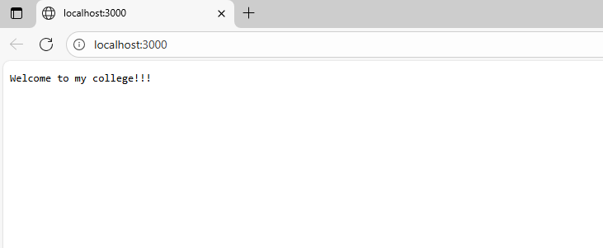

About page:
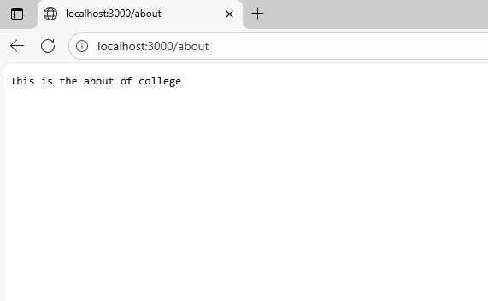

Contactus page:
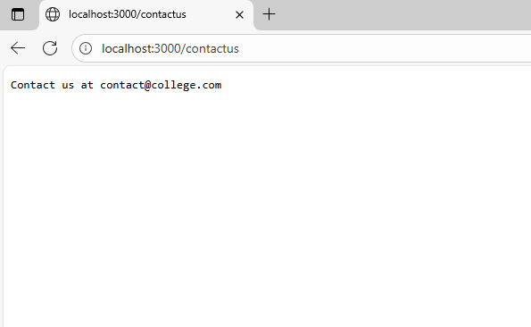

404 page:
